

**Modelling and Control of Brobekk Waste Incineration Plant**

**Håvard Pehrson**

Master of Science in Engineering Cybernetics

Submission date: June 2010

Supervisor: Morten Hovd, ITK

Co-supervisor: Sigurd Skogestad, IKP

Johannes Jäschke, IKP

Norwegian University of Science and Technology

Department of Engineering Cybernetics

# Problem description

Within the Oslo district heating network, several plants are used to heat up the water flowing through the pipe lines. One of these plants is Brobekk waste incineration plant. Brobekk sells its produced energy to Hafslund Fjernvarme AS, which runs the district heating network in Oslo.

This master thesis consists of studying and applying a new control structure at the Brobekk waste incineration plant. The first part comprises a literature study and learning how the existing process works, using a Simulink model and documentation from Brobekk.

The second part will be to improve the Simulink model using actual measured data, so that the model behaves more like the real process.

The final part will investigate whether it would be worthwhile applying a new type of process control. Candidates are either a Model Predictive Control (MPC) or a Nonlinear Model Predictive Control (NMPC). If possible, describe how to implement this in the best way. All the simulations will be done using MATLAB/Simulink.

Assignment given: 11. January 2010

Supervisor: Morten Hovd

# Abstract

Model Predictive Control of Brobekk waste incineration plant is the main focus of this master thesis. The motivation for using MPC at Brobekk is primarily to improve the control of the temperature towards the combustion furnace and towards Oslo.

The Brobekk plant is connected to Hafslund Fjernvarme through heat exchangers, and where temperature and flow from Hafslund heavily affects the temperatures within the Brobekk Plant. Based on temperature, flow and demand from Hafslund, the control region was divided into two distinct regions, where one of the regions could be divided in to four sub regions. Four separate Model Predictive Control structures were devised and they were all able to successfully control the temperatures towards the combustion furnace and towards Oslo. The transition between the two main regions was also investigated, and the control structure developed seemed to give promising results. For simulations, a model developed in an earlier master thesis was used. This model had to be modified, because some physical modification had been made at Brobekk the last year.

# Preface

This master thesis describes my work during the last semester at the Norwegian University of Science and Technology. The work is carried out at the department of Engineering Cybernetics, but the thesis is given by the Department of Chemical Engineering and Prediktor AS.

Acknowledgements and support goes to

* PhD student Johannes Jäschke at the Department of Chemical Engineering who has been a great help during my work on this thesis. He has given me many useful comments on the work in progress, and was always available for meetings and discussions.
* Helge Mordt at Prediktor AS who came up with this assignment and for valuable discussion regarding Brobekk waste incineration plant, how their control system is working today and what kind of problems they encounter with the control system they are currently using.
* Professor Morten Hovd at the Department of Engineering Cybernetics for being kind enough to take the task as a supervisor at this thesis, even though the thesis originally is given by the Department of Chemical Engineering.
* Professor Sigurd Skogestad at the Department of Chemical Engineering for a very interesting problem.

Finally, I want to thank my fellow students at the office; Morten Johannessen and Torgeir Myrvold for useful discussions regarding the master thesis work and model predictive controller. They have also been great opponents in our lunchtime card games.

Håvard Pehrson

June 2010

Contents

Problem description III

Abstract V

Preface VII

List of figures XI

List of tables XIII

Abbreviations XV

1 Introduction 1

1.1 Motivation 1

1.2 Structure of thesis 2

2 Background 3

2.1 Components at Brobekk 3

2.2 Operational aspects of Brobekk 5

2.3 Current control structure 6

3 Modelling 7

3.1 Work done by Helge Smedsrud 7

3.1.1 Modelling 7

3.2 Modifications taken into account in this thesis 10

3.2.1 Air heater 10

3.2.2 Frost protection 11

3.2.3 Minor adaptations made to the model 12

3.3 Input data to the model 13

4 Introduction to Model Predictive Control 15

*4.1* Historical development 16

4.1.1 LQG 16

4.2 Model predictive Control 17

4.2.1 The objective function 17

4.2.2 Internal model 18

4.2.3 Control interval 19

4.2.4 Prediction horizon 19

4.2.5 Control horizon 19

4.2.6 How to choose good interval and horizons 20

4.2.7 Constraints 20

4.2.8 Infeasibility 21

4.2.9 MPC Tuning 22

4.2.10 Square plants and non square plants 22

4.3 Nonlinear MPC 23

5 Process control theory 25

5.1 Control structure 25

5.2 Control challenges of heat exchangers 27

6 Implementation of MPC and simulations 29

6.1 MATLAB MPC Toolbox 30

6.1.1 Optimization problem 30

6.1.2 Prediction Model 31

6.2 Control challenges at Brobekk plant 32

6.2.1 Alpha region 33

6.2.2 Beta region 33

6.3 Control structure design 38

6.3.1 PI controllers 39

6.3.2 MPC design - Alpha region 42

6.3.3 MPC design - Beta region 43

6.4 Simulations 43

6.4.1 Alpha region 44

6.4.2 Beta region 48

6.4.3 Transition from alpha to beta region 55

6.4.4 Transition from beta to alpha region 58

7 Conclusion 63

8 Bibliography 65

Appendix A - List of symbols 67

Appendix B - Model parameters 69

Appendix C - Open loop step responses 71

# List of figures

Figure 2.1: Schematic overview of the Brobekk waste incineration plant. 4

Figure 3.1: Cell model of a heat exchanger. The middle element represents the wall side separating the primary and secondary side. 8

Figure 3.2: Air heater. 11

Figure 3.3: Frost protection. 12

Figure 4.1: The difference between sampling time, prediction and control horizon. 20

Figure 4.2: Process structure determines the degrees of freedom available to the controller. Adapted from Froisy (1994). 23

Figure 5.1: Control hierarchy (Skogestad, 2004). 25

Figure 5.2: Block diagram showing the two MPC alternatives. 27

Figure 6.1: Linear model for prediction and optimization. 31

Figure 6.2: Maximum outlet temperature, *Tout* as a function of flow rate. 33

Figure 6.3: The different sub regions at Brobekk. 35

Figure 6.4: Example how the gain changes when the plant is in operation. 36

Figure 6.5: Transition between different regions. 38

Figure 6.6: Air temperature towards the furnace and disturbances. 41

Figure 6.7: Temperature and flow inside air cooler. 42

Figure 6.8: Main flow at Brobekk. 42

Figure 6.9: Figure (a) shows furnace inlet temperature and figure (b) shows the heat exchanger secondary side outlet temperature in the α region. 46

Figure 6.10: Manipulated variables in the α region. 47

Figure 6.11: Flow, temperature and heat demand from Hafslund in the α region. 47

Figure 6.12: Figure (a) shows furnace inlet temperature and figure (b) shows the heat exchanger secondary side outlet temperature in the β region alternative 1. 50

Figure 6.13: Manipulated variables in the β region alternative 1 51

Figure 6.14: Flow, temperature and heat demand from Hafslund in the β region. 52

Figure 6.15: Figure (a) shows furnace inlet temperature and figure (b) shows the heat exchanger secondary side outlet temperature in the β region alternative 2. 53

Figure 6.16: Temperature towards Oslo in the β region alternative 2. 53

Figure 6.17: Flow secondary side Heat exchanger in the β region alternative 2. 54

Figure 6.18: Manipulated variables in the β region alternative 2 54

Figure 6.19: Figure (a) shows furnace inlet temperature and figure (b) shows the heat exchanger secondary side outlet temperature. Switching from α to β. 56

Figure 6.20: Manipulated variables. Switching from α to β. 57

Figure 6.21: Heat demand from Hafslund, Temperature in the Air cooler and MPC used. Switching from α to β. 58

Figure 6.22: Figure (a) shows furnace inlet temperature and figure (b) shows the heat exchanger secondary side outlet temperature. Switching from β to α. 59

Figure 6.23: Manipulated variables. Switching from β to α. 60

Figure 6.24: Heat demand from Hafslund and MPC used. Switching from β to α. 61

# List of tables

Table 2.1: Manipulated variables (MVs) at Brobekk waste incineration plant. 4

Table 2.2: Measured variables at Brobekk waste incineration plant. 5

Table 2.3: Main disturbances at Brobekk waste incineration plant. 5

Table 3.1: Symbols description. 9

Table 6.1: PI Controller parameters. 39

Table 6.2: Parameters for MPC constructed for α region. 45

Table 6.3: Parameters for MPC constructed for β region. 48

Table 6.4: Parameters for MPC constructed for β sub region 1. 55

# Abbreviations

|  |  |
| --- | --- |
| DHN | District heating network |
| EGE | Energigjenvinningsetaten |
| HEN | Heat Exchanger Network |
| LP | Linear programming |
| LQG | Linear quadratic Gaussian controller |
| MPC | Model predictive control |
| NMPC | Nonlinear model predictive controller |
| NTU | Number of transfer units |
| PI(D) | Proportional, integral (and derivative) |
| QP | Quadratic programming |
| RTO | Real-time optimizer |
| SIMC | Skogestad/Simple internal model control |
| WIP | Waste incineration plant |

# Introduction

This chapter gives a short introduction to the structure of this master thesis, as well as an introduction to waste incineration plants.

## Motivation

Waste incineration plants (WIP) are widely used around the world, and with today’s focus on climate and efficiency, the use of waste incineration plants as a source of energy becomes increasingly interesting. When waste incineration plants burn waste, the energy produced can be used to heat water. This heated water can then be used to provide heat to a district heating network (DHN) through the use of heat exchangers. Other possibilities are the production of electricity and steam.

Because of the high temperatures and pressures present in waste incineration plants it is required to have a reliable control system. An inadequate control system may lead to one or several conditions which all may have environmental or economical impact.

* Too high temperatures may lead to pipe damage.
* Too low temperatures may lead to unwanted condensation of acid and flue gas.
* Too high pressure can result in rupture of valves and bends.
* Too low pressure increases the risk of flashing.

Waste incineration plants may also experience grave disturbances from the district heating network (DHN), if the temperature from the DHN is too high or the flow is too low, both of which increases the risk of overheating and pipe-bending. On the other hand, if the temperature from the DHN is too low and the flow is too high, the plant may be cooled down, increasing the risk of condensation of acid and flue gas. These are potential disturbances which place many requirements on the control system at the waste incineration plant, where the main task for the control system is to keep the plant within its safety limits as well as to exchange available heat efficiently.

## Structure of thesis

Chapter gives a short overview of Brobekk Incineration plant, how it is connected to Hafslund Fjernvarme, and what kind of problems they encounter with the current control system.

Chapter contains the modelling part; the chapter gives a short review of the model which Helge Smedsrud developed in 2007/2008 and modifications made to the this model when working with this master thesis.

Chapter is included to give the reader a short insight into Model Predictive Control (MPC) and its historical development.

Chapter contains theory about process control and control challenges of heat exchangers.

In chapter , the implementation and simulation using the Model Predictive Control structure is given

And finally, chapter concludes the thesis by summarizing the most important results obtained and giving suggestions for further work to be done on the topic.

# 

# Background

The Brobekk and Klemetsrud waste incineration plants (WIP) are operated by the Waste recycling department of the city of Oslo (Energigjenvinningsetaten), henceforth called EGE. This thesis concentrates on Brobekk, located at Alnabru, built in 1967 and was the first large scale waste incineration plant in Norway. Brobekk burns waste from the surrounding area and the energy produced is used to heat pressurized water, which heats up water in a separate circuit through heat exchangers. This water comes from Hafslund Fjernvarme AS, henceforth called Hafslund, which operates the district heating network in Oslo city

The plant has been upgraded several times. In 2007, new heat exchangers were installed and later an air heater and a frost protection system were installed.

## Components at Brobekk

Brobekk has two heat exchanger lines, and each line consists of several components.

* A furnace, which burns the waste.
* An air heater, which heats up air used in the combustion process.
* An air cooler, which is used to remove excess energy when needed.
* A heat exchanger that transfer heat from Brobekk to Hafslund.

shows a process diagram for one of the two heat exchanger lines at Brobekk, as well as Hafslund’s side of the plant. The other line is not shown here, because they are identically built up and therefore assumed to have almost the same dynamic behaviour. The main disturbances are considered to be temperature and flow from Hafslund. The variables are explained in Table 2.1 through .

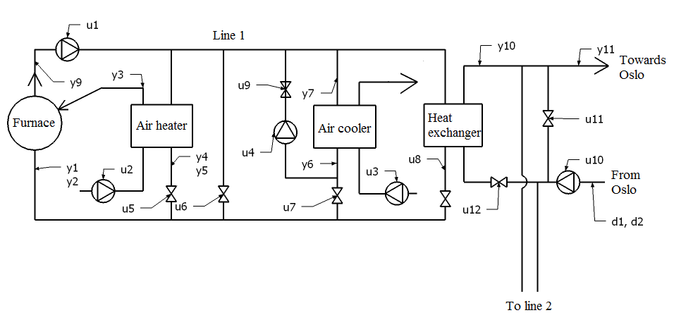

Figure 2.1: Schematic overview of the Brobekk waste incineration plant.

Table 2.1: Manipulated variables (MVs) at Brobekk waste incineration plant.

|  |  |  |
| --- | --- | --- |
| Shorthand notation | Description | Quantity |
| *u1* | Flow pump – Brobekk | 2 |
| *u2* | Air heater fan – Brobekk | 2 |
| *u3* | Air cooler fan – Brobekk | 2 |
| *u4* | Frost protection pump – Brobekk | 2 |
| *u5* | Air heater valve – Brobekk | 2 |
| *u6* | Bypass valve – Brobekk | 2 |
| *u7* | Air cooler valve – Brobekk | 2 |
| *u8* | Heat exchanger valve – Brobekk | 2 |
| *u9* | Frost protection shutoff valve | 2 |
| *u10* | Flow pump – Hafslund | 1 |
| *u11* | Bypass valve – Hafslund | 1 |
| *u12* | Heat exchanger valve – Hafslund | 2 |

Table 2.2: Measured variables at Brobekk waste incineration plant.

|  |  |  |  |
| --- | --- | --- | --- |
| Shorthand notation | Description | Quantity | Unit |
| *y1* | Furnace inlet temperature | 2 | °C |
| *y2* | Flow to furnace | 2 | kg s-1 |
| *y3* | Air temperature toward furnace | 2 | °C |
| *y4* | Air heater – Outlet temperature primary side | 2 | °C |
| *y5* | Air heater – Flow primary side | 2 | kg s-1 |
| *y6* | Air cooler – Outlet temperature primary side | 2 | °C |
| *y7* | Air cooler – Flow primary side | 2 | kg s-1 |
| *y8* | Heat exchanger – Outlet temperature primary side | 2 | °C |
| *y9* | Furnace outlet temperature | 2 | °C |
| *y10* | Heat exchanger – Outlet temperature secondary side | 2 | °C |
| *y11* | Temperature towards Oslo | 1 | °C |

Table 2.3: Main disturbances at Brobekk waste incineration plant.

|  |  |  |  |
| --- | --- | --- | --- |
| Shorthand notation | Description | Quantity | Unit |
| *d1* | Water temperature from Oslo | 1 | °C |
| *d2* | Flow from Oslo | 1 | kg s-1 |

## Operational aspects of Brobekk

Each furnace at Brobekk is capable of producing 16 MW, so the total energy produced is 32 MW. The total flow in each line is 250 tonne/h, and the furnace inlet temperature has to be 126°C, this gives a furnace outlet temperature at 180°C. If the furnace inlet temperature increases, the furnace outlet temperature will also increase, and if it becomes too high, the risk of boiling in the pipes increases. In order to decrease the furnace outlet temperature, the control system stops the fans that blow air to the furnace. This reduces or even stops the combustions process, but it also leads to more emission of the gas CO. It is therefore crucial that the furnace inlet temperature follows it setpoint, within a deviation of ±3°C. This is possible through the use of either a hot bypass or an air cooler, depending on how much energy Hafslund consumes. The furnace inlet temperature is given by a combination of the temperatures and flows from the air heater, the bypass, the air cooler and the heat exchanger. Another actuating quantity is opening and closing of valves in the plant. Because the plant is a closed system and the total flow is 250 tonne/h, controlling a valve will affect the flow through the other valves in the plant.

The water temperatures from Hafslund can vary between 65 to 90°C and water temperatures that Hafslund wants towards Oslo can vary between 95°C to 110°C. The flow rate can vary between 500 and 900 tonne/h, and is divided equally between the two heat exchanger lines.

One of the largest problems Brobekk encounters is when Hafslund, because of less heat needed, drastically reduces their flow towards the heat exchangers. If the heat needed from Hafslund drops below 32 MW, Brobekk has to remove excess energy using air coolers. When this happens it has been measured that the furnace inlet temperature, decreases a little bit, before it increases beyond limits. These patterns seem to be valid, and it will be the main thesis to investigate if an MPC or a nonlinear MPC can perform better than the current control structure.

## Current control structure

Today the control structure at Brobekk is divided between EGE and Hafslund, in such way that they control their specific side of the heat exchangers: EGE controlling the primary side and Hafslund controlling the secondary side and where the two control systems fight each other. Intuitively, this doesn’t seem like an ideal control structure, and it would be better to let one party control the heat exchanger. But because of various reasons, none of the parties will give up its control structure. To make it more confusing, both parties can also control some of the valves at both sides of the heat exchangers, where minimum or maximum selectors are used to determine which controller that is used for control. This makes the control system rather difficult to understand and more complex than it needs to be.

Hafslund uses the bypass valve *u11*to control the water temperature towards Oslo and the valves *u12* are used to split up the flow so that there is an equal amount of mass flow towards each heat exchanger.

# 

# Modelling

This chapter gives the reader some insight to the work done by Helge Smedsrud as well as modelling done in this master thesis.

## Work done by Helge Smedsrud

Master student Helge Smedsrud worked with almost the same problem description in his master thesis from 2007/2008 (Smedsrud, 2008). He developed a model of the Brobekk plant in Simulink and used this model to study a self-optimizing control structure. His thesis divided the control region into 4 distinct regions, depending on temperature and flow from Hafslund. Using a self-optimizing control approach, he found an optimal control structure and setpoints for each region. In order to controlling the bypass valve, heat exchanger valve, air cooler fan and valve at Brobekk’s side, it was also necessary to control valves at Hafslund’s side of the heat exchanger.

There have been identified some weaknesses in this control structure. The first is that Smedsrud are using valves, which EGE are not able to control; these are the valves *u11*and *u12* on the Hafslund side of the heat exchanger. If EGE were given control over these valves, Hafslund would not be able to control the temperature towards Oslo and the temperature of the hot water going to Oslo could vary a lot. Simulation results proved that the furnace inlet temperature followed it setpoint well, but the temperature towards Oslo varied a lot when Hafslund wanted to take out less that 32 MW. Another weakness in this control structure is that Smedsrud is using the Bypass valve at Hafslund side to control both the heat exchanger lines at Brobekk. From a control point of view, it is impossible to use one manipulated variable to control two variables. He decided to do this, because he assumed that both lines are identical, but this is unlikely in a real situation.

### Modelling

For the furnaces Smedsrud uses a Number of Transfer Units or NTU method (Hertzberg, 2008, Mathisen ,1994), which approximates a heat exchanger, but without the dynamic behaviour that is present in heat exchangers. The NTU model of the furnace is designed such that when the flow through the furnace is 250 tonne/h and the furnace inlet temperature is 126°C, the furnace outlet temperature is 180°C.

For the heat exchangers he uses a lumped compartment or “multi-cell” model (Mathisen, 1994). The “multi-cell” model approximates a partial differential equation where the heat exchanger are divided into perfectly and instantly mixing cells, where each cell features a primary side, a wall and a secondary side element. In the model, Smedsrud uses ten cells, all having identical properties. shows how the heat exchangers are modelled.

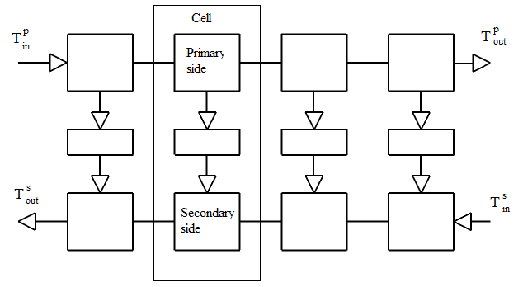

Figure 3.1: Cell model of a heat exchanger. The middle element represents the wall side separating the primary and secondary side.

The ordinary differential equation is given below and symbols are described in .







Table 3.1: Symbols description.

|  |  |  |
| --- | --- | --- |
| Shorthand notation | Description | Unit |
| *T* | Temperature | °C |
| *t* | Time | Second |
| *h* | Heat transfer coefficient | W m-2 K-1 |
| *A* | Heat transfer area | m2 |
| *w* | Mass flow rate | kg s-1 |
| *cp* | Specific heat capacity | J kg-1 K-1 |
| *N* | Number of cells | - |
| *ρ* | Density | kg m-3 |
| *V* | Volume | m3 |

Superscript *p, w* and *s* denotes primary, wall and secondary side respectively.

For the fans, Smedsrud uses the Bernoulli equation where he assumes low pressure drop across the fan and a horizontal position.



where 𝜂 is efficiency, A is area, *ρ* is density, *w* is mass flow rate, and *p* pressure.

The Bernoulli equation is also used for the pumps, where the elevation was set to zero, the diameter was assumed equal before and after the pump, and the pressure after the pump was assumed constant.



where 𝜂 is efficiency, *ρ* is density, *w* is mass flow rate, *P* power, and *p* pressure.

The valves were modelled using a standard valve equation.



where *Q* volumetric flow rate*, Kv* is valve constant, *ρ* is density, and *p* is pressure.

For mixing the flows Smedsrud uses a simple expression, under the assumption of an instant and homogeneous mixing.

Smedsrud also made some simplifications and assumptions:

* *Since the system only contains pressurized water and non compressed air, all thermo dynamic and material properties like heat capacities and densities were assumed constant and average values for the respective temperatures were used.*
* *Pressure drops over heat exchangers were ignored, because this is very small for modern heat exchangers*
* *Isothermal flow was assumed through pumps, fans and valves due to the low pressure differences in the system.*

The same simplifications and assumptions were used during work with this thesis.

The reader is encouraged to read Smedsrud’s master thesis (Smedsrud, 2008) for more detailed information about the model.

## Modifications taken into account in this thesis

In 2008 and 2009, several physical modifications were implemented at Brobekk, and these modifications had to be implemented in the model Smedsrud developed, before a model predictive controller could be implemented. This section gives a review of these modifications made.

### Air heater

In order to have a better and more stable burning process, it was decided to install air heaters. The air heaters heat up air that is used in the furnace. EGE uses the heated water produced at Brobekk to heat up the air. The air is heated to 90°C before it is fed into the combustion process. The maximum total energy used to heat up the air is approximately 650 kW, which is about 4 percent of the total amount of energy produced at Brobekk.

The air heater was modelled using the same heat exchanger model structure Smedsrud used, but without the wall element and using 9 cells. The parameters were adjusted to give correct steady state values, and are given in appendix B. A design specification on the air heater gives a primary side outlet temperature at approximately 145°C with a flow rate at 4.5 kg/s at the primary side and a flow rate at 6 kg/s at the secondary side. shows the air heater.

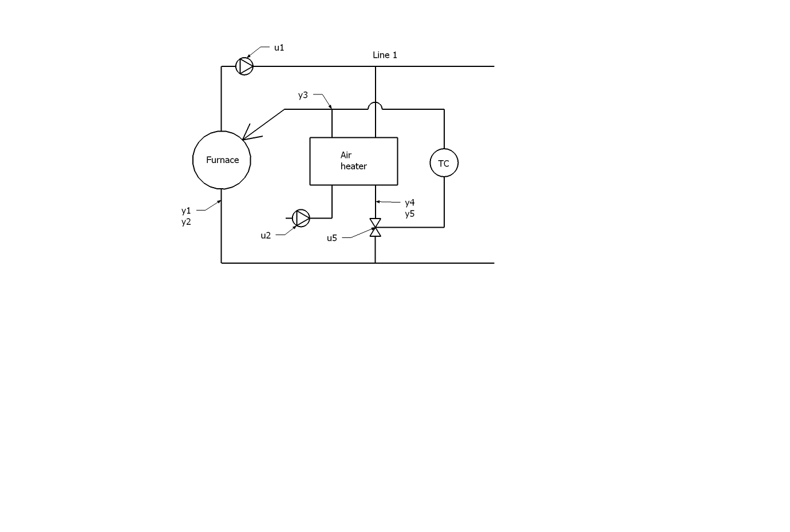

Figure 3.2: Air heater.

### Frost protection

The other main modification at Brobekk was the installation of the frost protection equipment in the air cooler. This was implemented in 2008, because in December 2007/January 2008 the air cooler was damaged due to water freezing inside the air cooler. The frost protection systems consists of a flow controller that ensures that the flow through the air cooler always is 15.125 kg/s (60 tonne/h) and a temperature controller that ensure that the temperature in the air cooler never comes below 10°C. The flow controller controls a pump, which pumps water from outlet primary side to the inlet primary side of the air cooler. The pump only operates when the outside air temperature is below 5°C. The temperature controller controls the air cooler valve, where hot water from the furnace is used to heat up the water temperature inside the air cooler.

To keep the Simulink model simple, it was decided to not to model the flow controller or the pump, instead a statement was made, where the flow driven by the pump was set to 15.125 kg/s subtracting the flow through the air cooler valve. By making this statement, the flow through the air cooler always is 15,125 kg/s, but the flow driven the pump can vary. If the flow through the air cooler valve is larger than 15.125 kg/s, the flow driven by the pump is set to zero. The statement is only valid if the outside air temperature is below 5°C. The temperature controller was modelled like a PI controller. The frost protection system is shown in .

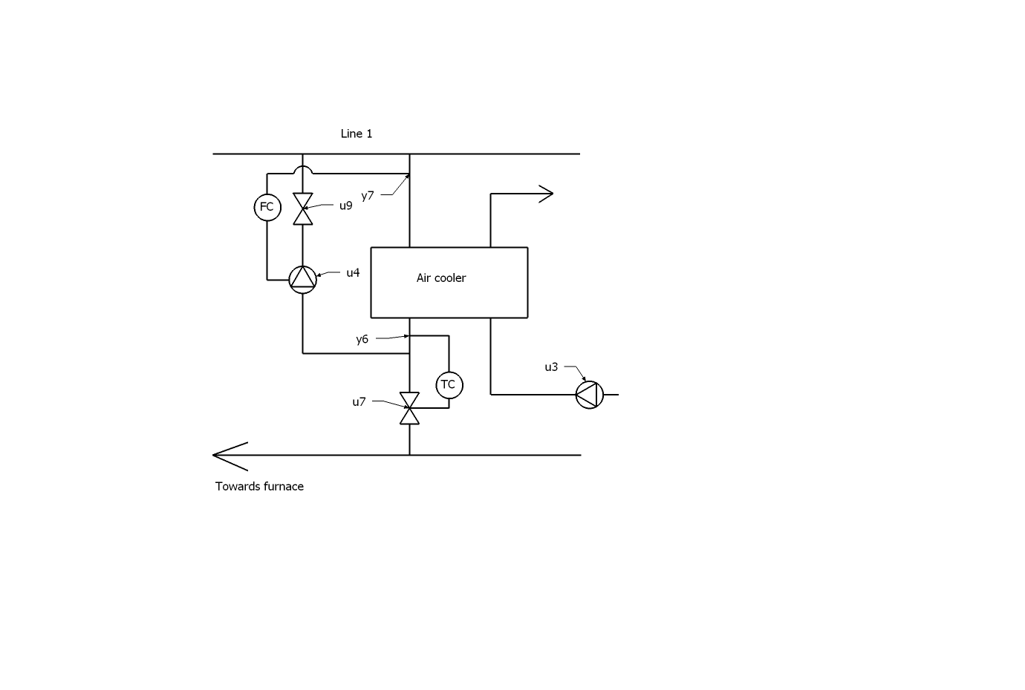

Figure 3.3: Frost protection.

### Minor adaptations made to the model

Because the model developed by Smedsrud was designed for a slightly different purpose, some minor adaptations had to be included in the model.

##### Flow mixers

As mentioned earlier, Smedsrud uses a simple expression below for mixing the flows. The expression is given in equations and





Consideration of equation reveals that the temperature will be infinity, if the total flow, *Wtot*, is equal to zero. To circumvent this, a simple statement was implemented, setting the outlet temperature, *Ttot ,* equal to inlet temperature, if the total flow is zero. This statement was only used when mixing the frost protection feedback flow and the flow through the air cooler valve, because this is the only situation where the model can have zero flow through a mixer. Zero flow through this flow mixer happens when the frost protection system is unused, i.e. the air temperature is higher than 5°C and the air cooler valve is closed.

##### Anti windup in PI controller

Anti windup was not implemented in the PI controllers Smedsrud developed. This allowed the integral action in the PI controllers to windup, causing some incomprehensible simulation results. The PI controllers were therefore modified to include anti windup.

## Input data to the model

As mentioned in the problem description, one task was to use actual measured data in order to improve the dynamic behaviour in model. In discussion with Johannes Jäschke, it was decided not work further with this task. It was assumed that the model already had all the similar characteristics as the real plant. Some of the gains and time constant in the model might be different from the real plant, but it would not be worthwhile to spend effort on this task.

# 

# Introduction to Model Predictive Control

Predictive Control, or Model-based Predictive Control, MPC, is the only advanced control technique – that is, more advanced than standard PID control – to have had a significant and widespread impact on industrial processes (Maciejowski, 2002). It has mainly been used in petrochemical industry, but has gradually gained interest in other sectors of control engineering, such as control of airplanes and vehicles.

The main reasons for this are that MPC is (Maciejowski, 2002).

* *The only control technology which can deal routinely with equipment and safety constraints.*
* *The underlying idea is easy to understand.*
* *Its basic formulation extends to multivariable plants with almost no modification.*
* *It is more powerful than PID control, even on ‘difficult’ loops such as those containing long time delays.*

The development of MPC started about 40 years ago, but it is difficult to assign the beginning to one person or one company because the ideas seems to have been proposed by several authors more or less simultaneously. Lee and Markus (1967) anticipated current MPC practice in their 1967 text on optimal control:

|  |
| --- |
| *One technique for obtaining a feedback controller synthesis from knowledge of open-loop controllers is to measure the current control process state and then compute very rapidly for the open-loop control function. The first portion of this function is then used during a short time interval, after which a new measurements of the function is computed for this new measurements. The procedure is then repeated.* |

The earliest patent, however, appears to be that granted to Martin-Sanchez in 1976 who called his method simply *Adaptive Predictive Control* (Maciejowski, 2002)*.*  In the following years several authors proposed different predictive control methods. But all these proposals shared the essential feature of predictive control; an explicit use of an internal model, the receding horizon idea and computation of the control signal by optimizing future plant behaviour. The following section gives a short summary about the methods that can be considered the breakthroughs in model predictive control.

## Historical development

### LQG

The *linear quadratic Gaussian* (LQG) controller was the first concept of a modern control concept. It can be traced back to the work of Kalman in the early 1960s. Kalman and co-workers described a discrete-time, linear state-space system model (Qin & Badgwell, 2003)



where vector *x* is the process states to be controlled, vector *u* represents the input or manipulated variables and vector *y* represents the measured variables. Vector *w* represents the state disturbance and vector *v* represents the measurement noise. Both *w* and *v* are assumed to be Gaussian with zero mean. They defined an objective function *J*, where they minimized the deviation between the expected values of the squared states and input from the origin.



They also added weight matrices *Q* and *R* to the objective function; this allowed them to tune the controller to perform as they wished. *Q* puts weights on deviation of states and *R* puts weight on deviation of inputs. More weight on *Q* causes the controller to move the states to its setpoint faster. *Q* has to be positive semi-definite and *R* has to be positive definite to ensure that the objective function is convex. A convex optimization problem always has a unique optimal solution, and can easily be solved using commercial mathematical products like MATLAB.

The solution to this problem involves two steps; first the outputs measurement *y* at time *k* is used to obtain an optimal state estimate 



where *Kf* is the Kalman filter gain, and is computed from the solution of a matrix Ricatti equation (Qin & Badgwell, 2003).

Second; an optimal input *uk* is computed using an optimal proportional state controller. The LQG controller has good stabilizing properties; given that the linear internal model is almost identical to the real plant. One big drawback for the LQG controller is that it doesn’t handle constraints on inputs and states.

## Model predictive Control

The major difference between today’s MPC technology and to ordinary LQG is that MPC handles constraints on inputs, states and outputs. This is an important feature, because a plant almost always have constraints on input and also often on states and outputs.

There are several variants of the MPC, but they all share common trait that an explicitly process model is used to predict and optimize future process behaviour (Hovd, 2009). The following section presents some of the features that are common and important for MPCs. The discussion given here will focus on linear MPC.

### The objective function

The objective function in the MPC contains all the variables that are weighted, that are all inputs and all outputs that are of interests, but it can also be states that indirectly improve an output that can be difficult to measure correctly. The optimization problem is typically cast into one of two standard forms (Hovd, 2009):

* *Linear programming (LP) formulation, where both the objective function and constraints are linear.*
* *Quadratic programming (QP) formulation, where the objective function is quadratic and whereas the constraints have to be linear.*

A quadratic objective function generally gives smoother control and more intuitive tuning parameters (Hovd, 2009). In the LQR algorithm, the objective function given by equation is defined over an infinite horizon and it takes into account infinite number of steps into the future. This is only possible when there are no constraints in the optimization problem. For a MPC with constraints in the formulation, this problem can be avoided by dividing the objective function in two parts (Imsland, 2007);



where N is the prediction horizon. The control moves in the first part are free optimization variables and in the second part, the control moves can either be a constant or obtained by the LQR controller. Splitting the objective functions in two parts is the key to some closed loop stability proofs for MPC (Imsland, 2007).

### Internal model

The Model Predictive Controller needs an internal model. The internal model is used to predict future plant behaviour over a future prediction horizon, starting at the current time. This predicted plant behaviour depends on the predicted inputs trajectory. The idea is to select inputs which give the best predicted behaviour with respect to the objective function. The model can either be a state space model or a transfer function and may be linear or nonlinear. Linear models are easier to solve than nonlinear, and there are many well known algorithms for solving linear optimization problem. Ideally, the internal model should behave similar to the real process in order to achieve good control in practice. If the model does not exhibit similar characteristics to those of the real plant, the MPC would have difficulties finding the optimal inputs to the process.

### Control interval

An MPC generates a discrete-time controller, which is a controller that takes action at regular discrete time instants, in other words, applies new computed inputs to the plant. This is often referred to as sampling time. The time that is separating each sampling interval is often referred to as control interval. One would have a small control interval, because the MPC could adjust faster for deviation in measured outputs. But too small a control interval would also lead to failure, due to the fact that the MPC cannot finish the computation in time. It can also be dangerous to set the control interval too large because this might lead to bad closed loop performance. One can say that the control interval should be at least as long as the computation time, but not so long that it will affect the closed loop performance. With modern computer power, short control intervals are usually not a large problem, as long as the optimization problem is linear and there are not too many variables to optimize.

### Prediction horizon

The prediction horizon is the time horizon which the controller predicts the future outputs when computing controller moves. In addition to having an effect on closed loop performance, the prediction horizon also affects the complexity of the computation. One can usually say that a large prediction horizon gives larger complexity and better closed loop performance, whereas a small prediction horizon gives the opposite. From a control point of view, one can say that the prediction horizon should be limited by computational bounds, but this might not always be a good choice. One always has model mismatch, due to nonlinearities, simplifications and modelling errors, and these uncertainties tend to be amplified as one predicts far into the future (Imsland, 2007).

### Control horizon

The control horizon is the number of future optimal control moves computed at each sampling time. At the next sampling time, a new optimal control input is computed. shows the difference between control interval, and prediction and control horizon (MATLAB Model Predictive control toolbox, user guide, 2004).

### How to choose good interval and horizons

It can be difficult to choose correct values for control interval, prediction and control horizon, but some rules of thumb for lag dominant, stable processes have been proposed. (MATLAB Model Predictive control toolbox, user guide, 2004)

1. *Choose the control interval such that the plant’s open loop settling time is approximately 20-30 sampling periods, (i.e., the sampling period is approximately one fifth of the dominant time constant)*
2. *Choose the prediction horizon to be the number of sampling periods used in step 1*
3. *Use a relatively small control horizon, e.g., 3-5.*

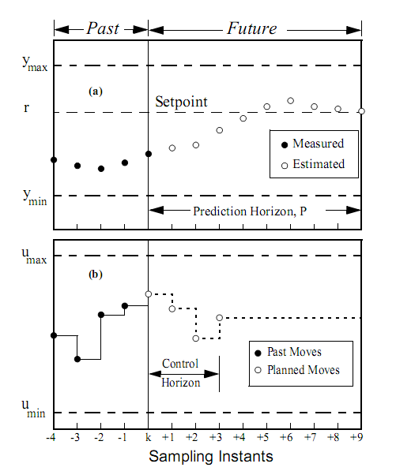

Figure 4.1: The difference between sampling time, prediction and control horizon.

### Constraints

In almost every plant there are constraints on inputs and in several cases, also on outputs. For instance a valve can never be more than fully open or it is desirable to keep an output within a lower and upper bound. There are two kinds of constraints, hard constraints and soft constraints. Hard constraints are constraints that cannot be violated under any circumstances; the MPC will always try to satisfy hard constraints before any other constraints or setpoints. It is most common to put hard constraints on input variables, such as valves, pumps and so on, because this is equipment that has a physical limit. It is also possible to put constraints on how much an input can move in each time step. It can be risky to have hard constraints on an output, because the MPC will ignore its other objectives in order to satisfy them, causing other outputs to be driven away from their setpoint. Soft constraints are constraints that can be violated to satisfy other constraints. The constraints can be written in the following form.



where *u* is the input vector, ∆*u* is the input change from one control sampling time to the next, and *y* is the output vector. They can be written compactly (Imsland, 2007)



where *Dx* and *Dy* are matrices that must be constructed,andare vectors of suitable dimension, and *u* is the input vector and *x* is the output vector.

### Infeasibility

In some cases, the MPC encounters a situation where all the constraints cannot be satisfied, this may happen when large disturbances affect the process. This situation is called infeasibility and it is important that the MPC can handle such situations. One way to cope with infeasibility is to temporarily remove the constraints, which are violated, from the optimization and then add the constraints when the output returns to its feasible area. Another alternative is to use soft constraints instead of hard constraints; this will cause the MPC to try to satisfy all its objectives without removing constraints that are violated.

### MPC Tuning

As mentioned in chapter , it is possible to tune the controller with the matrices *Q* and *R*. Different values of *Q* and *R* matrices will give different performances. Consideration of the objective function given in equation reveals that *Q* penalizes deviation of states and outputs and *R* penalizes deviation between the optimal input and their setpoint value. Increasing the weights on the *R* matrices relative to the weights on *Q* will reduce the control activity and may even reduce the control activity to zero, causing steady state error on states and outputs. Too large weights on *R* will also give slow response to disturbances. Different values of the diagonal *R* matrix elements will cause one input to move more than another input. Suppose that two inputs have an almost identical influence on an output, then the MPC will use the input, which has the lowest weight to bring the output to its setpoint. The same goes for the weights in the Q matrix: The MPC will try to keep a state or output, which has a larger weight, at its setpoint, prior to a state or output with lower weight. Other aspects that affect the tuning are the disturbance model and the observer dynamics.

### Square plants and non square plants

In the real world, process inputs and outputs can be lost due to valve saturation, hardware failure and so on, this means that the structure of the control problem and degrees of freedom for control can change dynamically during operation. illustrates how the process can change. In the “thin” plant, there are not enough inputs to meet all the control objectives and outputs may move freely. The control specification needs to be relaxed or the output violation can be minimized in some mean square sense (Qin & Badgwell, 2003). In the square plant, the amount of inputs is equal to the amount outputs and the MPC is able to meet the control objectives. In the “fat” case, which is more common, the plant has more inputs than outputs. The input values needed to achieve a particular setpoint would be non unique, thus the inputs would drift within their operating space. One way to avoid this is to use setpoints for extra inputs. These setpoints are usually defined beforehand and may represent operational condition that improves economical return, safety et cetera.

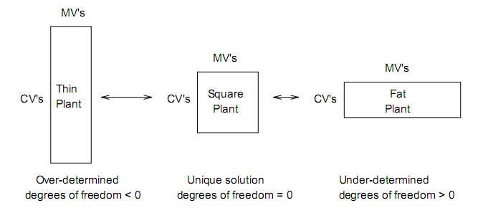

Figure 4.2: Process structure determines the degrees of freedom available to the controller. Adapted from Froisy (1994).

## Nonlinear MPC

Nonlinear Model Predictive Control is a variant of the linear model predictive control (MPC). The difference between the nonlinear MPC and the linear MPC is that the nonlinear MPC uses a nonlinear model to predict future plant behaviour. While for the linear MPC, the optimization problem is convex, and it is therefore possible to determine the computational time for each optimization step. The optimization problem for nonlinear MPC is generally non-convex, which imposes challenges for both numerical solution and stability. It is therefore hard, or impossible to determine the computational time for each optimization step, and one can therefore not guaranty if the optimization will complete in time. Since the optimization problem is non-convex, one can in addition to the global optimal solution, which is the preferred solution, also have many local optimal solutions. If the optimization algorithm converges to an optimal solution, it is impossible to say if the solution found is a global optimal solution or not, because the algorithm can as well converge to a local optimal solution.

In practice, linear MPC give good performance, so it often not worth to invest time and money to implement a non-linear MPC, and due to the simple structure, linear MPC is easier to maintain.

# 

# Process control theory

In this chapter some theory for process control and heat exchangers are given.

## Control structure

It is quite common to divide the control system into several layers, where each layer is separated by a time scale. The layers are shown in .

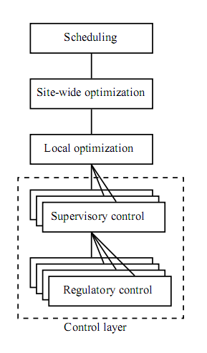

Figure 5.1: Control hierarchy (Skogestad, 2004).

where the supervisory control and regulatory control can be seen as the control layer. The regulatory control layer often exists of single-input single-output PID control loops that are used for stabilization and local disturbance rejection by controlling selected “secondary” variables. The supervisory control layer consist of more advanced control system, typically a MPC, and is used to keep primary outputs at their setpoint by controlling setpoints for the regulatory control layer. The layers above can be seen as an overall optimization layer that involves the whole plant and is controlled by an overall real time optimizer (RTO).

The different layers also operate on different time scales. The top layer works on a weekly or monthly basis, where the task is to schedule how the plant shall run the next weeks or months. The site-wide optimization works on a daily, and the optimization layer work on an hourly basis where a real time optimizer uses a model of the plant to compute new optimal setpoints for supervisory level. This model is often a nonlinear steady state model, which has to be maintained, so it matches the current plant conditions. The supervisory level works on a smaller timescale, like minutes, while the regulatory layer works on an even smaller timescale, seconds.

If an MPC is used at supervisory control layer, a regulatory layer is not required, because the MPC is able to directly control physical inputs. However, since MPCs are more complex and their sensitivity to errors and failure are quite unpredictable, such controllers are usually avoided at the bottom control hierarchy (Skogestad, 2004). Another alternative is to have the MPC at the supervisory layer control setpoints for regulatory layer. This will ensure that the plant is running even if the MPC fails, thus making the control system more failure tolerant.

The decentralized controllers should be tuned properly in order to obtain a good time scale separation between the control layers. By doing this, there will be several advantages according to Skogestad & Postlethwaite (2005):

* *The stability and performance of a lower (faster) layer is not much inﬂuenced by the presence of upper (slow) layers because the frequency of the ”disturbance” from the upper layer is well inside the bandwidth of the lower layer.*
* *With the lower (faster) layer in place, the stability and performance of the upper (slower) layers do not depend much on the speciﬁc controller settings used in the lower layers because they only affect high frequencies outside the bandwidth of the upper layers.*

These items emphasize the importance of well tuned controllers in the lowest layer.

This thesis will focus on the lower layers in the control structure, and therefore the higher layers will not be taken into consideration in this thesis.

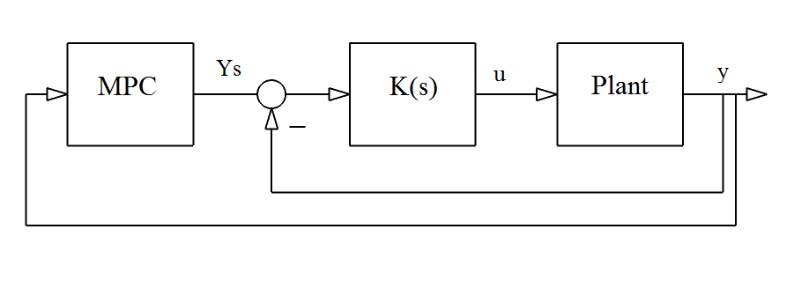

(a) MPC controls setpoints for lower layer controllers.

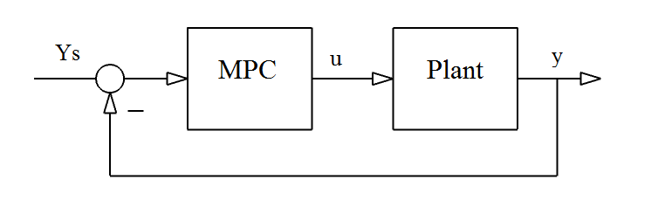

(b) MPC controls directly on physical inputs.

Figure 5.2: Block diagram showing the two MPC alternatives.

## Control challenges of heat exchangers

Heat exchanger networks (HEN) have been considered to be extremely nonlinear (Shinskey, 1979). Both thermal effectiveness and heat transfer coefficients depend on the flow rate through the heat exchanger, and this in the main cause for the nonlinearities (Mathisen, 1994). In addition to the non-linearity, right half plane zeros and time delays imposes fundamental limitations if control performance.

* Plants with right half plane zeros may have inverse response and therefore fast and efficient control are impossible with simple PID controllers. However with the use of Model Predictive Control, the control performance can be improved compared to simple PID controllers.
* For HENs time delays are due to mass and energy holdup in heat exchangers and mass holdup in pipes, and this also imposes a limitations of control performance (Zeigler and Nichols, 1943; Rosenbrock, 1970). It is assumed that the time delays at Brobekk are very small, because of fast flow rate through the pipes, and is therefore neglected in the model.

The outlet temperatures from a heat exchanger can independently be controlled by manipulating the inlet temperatures. But usually the inlet temperatures cannot be manipulated, and one will therefore have to use the primary and secondary sides flow rates to control the outlet temperatures. However, if the flow rate at one of the side of the heat exchanger is fixed, i.e. not a manipulated variable, it is impossible to control both outlet temperatures independently, i.e. one can only control one of the outlet temperatures.

# 

# Implementation of MPC and simulations

As mentioned in the problem description, one of the tasks was to investigate whether it would be worthwhile to apply either an MPC or a Nonlinear MPC for controlling the real plant. Considering the discussion in chapter regarding nonlinearities of heat exchangers, a nonlinear MPC would theoretically be preferred for controlling the real plant; however, due to the practical difficulties regarding nonlinear MPCs discussed in chapter we propose not to use a nonlinear MPC. However, with the use of linear MPC for controlling the plant, an alternative is to have several MPCs for different operating points and then switch between them to account for non-linear behaviour.

However, in this thesis, it was decided to use MATLAB’s Model Predictive Control Toolbox, which is a linear MPC. The main reasons for this are:

* The model developed by Smedsrud is made in Simulink, which is a supplementary package to MATLAB.
* The Model Predictive Control Toolbox provides Simulink blocks and MATLAB functions for designing and simulating model predictive controllers both in MATLAB and Simulink. It is therefore easy to connect the model with a model predictive controller.
* The dynamic heat exchanger model derived in uses linear differential equations. It would not make any sense to use a nonlinear MPC.
* MATLAB is in use in the in industry and can be used directly or linked with other software packages.

The rest of this chapter presents the different MPCs alternatives that were designed for the model of Brobekk waste incineration plant, and hopefully the results can be valuable in order to solve the problems described in chapter

First, some theory on how the Model Predictive Toolbox works is presented. Secondly, control challenges discovered at Brobekk are described. Lastly, simulation results are present.

## MATLAB MPC Toolbox

This section contains a little discussion of the Model Predictive Control Toolbox, but the toolbox is described in greater detail in the MathWorks tutorial, Model Predictive Control Toolbox, user guide, v2, 2004.

### Optimization problem

The optimization problem to be minimized is written:



Subject to



where the subscript *j* denotes the *j-th* component of a vector, *k+i|k* denotes the value predicted for time *k*+*i* based on the information available at time *k; r* is the reference for all measured and unmeasured outputs, *p* is the prediction horizon, *m* is the control horizon and *ny* and *nu* are the dimension of the input vector and output vector.

The optimization problem minimizes the objective function using information from the present time step *k* to *m−1+k* and the slack variable ε as optimization variables. In equation , constraints are relaxed by introducing the slack variable ε ≥ 0. The weight *ρε* on the slack variable ε penalize the violation of the constraints. The larger weight with respect to manipulated variable and measured output weights, the more the constraint violation is penalized (Model Predictive Control Toolbox, user guide, v2, 2004).

### Prediction Model

MPC toolbox uses a linear model for prediction and optimization, and the idea is shown in .

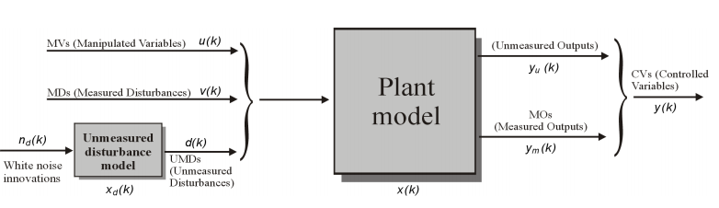

Figure 6.1: Linear model for prediction and optimization.

The model consists of

* A linear model of the plant to be controlled
* A model for generating unmeasured disturbances

The linear time invariant system can be described by the equation:



Where *x*(*k*) is the state vector, *u*(*k*) is the manipulated variables, *v*(*k*) is the measured disturbance vector, *d*(*k*)is the unmeasured disturbance vector, *ym*(*k*) is the measured outputs and *yu*(*k*) is the unmeasured outputs. The overall output vector *y*(*k*)collects *ym*(*k*) and *yu*(*k*)*.*

If an unmeasured disturbance model is not specified, the toolbox will generate one, assuming that the disturbances are integrated white noise. The unmeasured disturbance model is also modelled as a linear time invariant system.



Where *nd* is random Gaussian noise which have zero mean and unit covariance matrix.

## Control challenges at Brobekk plant

Brobekk waste incineration plant is a quite challenging plant to control, as Hafslund can try to take out more than 32 MW or they may want to take out less than 32 MW. It is therefore possible to split the control into two regions, one when Hafslund try to takes out more than 32 MW, which is called α (alpha), and another, which is when Hafslund takes out less than 32 MW, which is called β (beta). The heat demand *q* from Hafslund can simply be found by using the steady state energy balance for heat exchangers below.



Where *cp* is the specific heat capacity, *w* is flow rate. *Tout* and *Tin* represents outlet and inlet temperatures, and *q* is heat exchanged. Consideration of equation , reveals that *Tout* depends on the flow rate *w*, the specific heat capacity *cp,* heat demand *q,* and secondary side inlet temperature *Tin*. The maximum outlet temperature, *Tout* can therefore be plotted as a function of flow rates at various inlet temperatures from Oslo. If the desired temperature that Hafslund wants towards Oslo is above the maximum outlet temperature, Hafslund wants to take out more than 32 MW and vice versa. All curves are calculated based on *q* = 32 MW. The maximum outlet temperatures are shown in .



Figure 6.2: Maximum outlet temperature, *Tout* as a function of flow rate.

### Alpha region

The α region, defined as when Hafslund wants 32MW or more, is simple to control. Since EGE never can achieve the desired temperature that Hafslund wants, the only control objective is the furnace inlet temperature, y1.

### Beta region

The β region, defined as when Hafslund wants less than 32MW, is more challenging; in addition to controlling the furnace inlet temperature, the heat exchanger secondary side outlet temperature, *y10*, should also be controlled. In this region, EGE has to use the air coolers to remove the excess energy. A result of learning how the process works, it was found that β region should be divided into 4 different sub regions, based on the following factors

* Furnace inlet temperature.
* The heat exchanger primary side outlet temperature.
* The air cooler primary side outlet temperature.

We will first explain the characteristics of each sub region, and why different sub regions imposes control difficulties when using MPCs. At last we will explain why some of these sub regions can be undesirable to operate in. shows an overview over the different sub regions.

##### Sub region 1

The first sub region is when both the air cooler primary side outlet temperature, *y6*, and the heat exchanger primary side outlet temperature, *y8*, are lower than the furnace inlet temperature, *y1*. The only way that EGE can keep the furnace inlet temperature at it setpoint, is to use the bypass valve.

The air cooler primary side outlet temperature is low due to cold air cooling the water inside the air cooler when the air cooler is not used, and therefore the plant will always be in this sub region when going from the α region the β region. As the air cooler valve opens further, hot water will flow through the air cooler, and at one point, the air cooler primary side outlet temperature, *y6*, will become higher than the furnace inlet temperature. This brings the plant to the second sub region.

##### Sub region 2

This sub region is described by the air cooler primary side outlet temperature, *y6*, is higher than the furnace inlet temperature, *y1*, and the heat exchanger primary side outlet temperature, *y8* is lower than the furnace inlet temperature, *y1*.

##### Sub region 3

In the third sub regionthe air cooler primary side outlet temperature, *y6*, is lower than the furnace inlet temperature, *y1* and the heat exchanger primary side outlet temperature, *y8*, is higher than furnace inlet temperature, *y1*.

In this sub region and in *sub region 2*, EGE can keep the furnace inlet temperature at its setpoint with the flow from the air cooler and heat exchanger, without using the bypass valve.

##### Sub region 4

The fourth sub region when both air cooler primary side outlet temperature, *y6* and the heat exchanger primary side outlet temperature, *y8* are higher than the furnace inlet temperature, *y1*. However, this region has not been considered in this thesis, because this sub region is not permitted to operate in. There are no ways that EGE can keep the furnace inlet temperature at its setpoint when operating in this sub region.

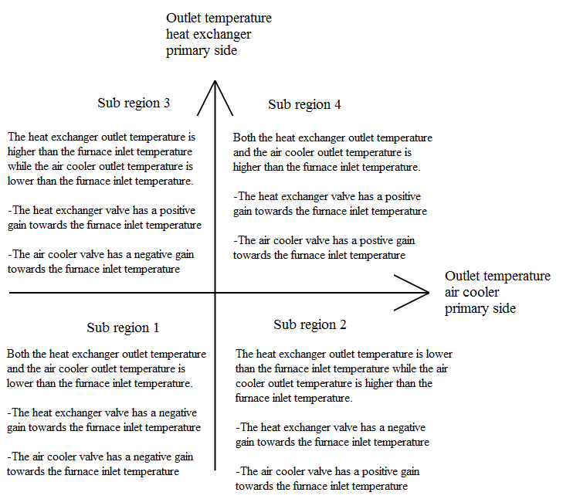

Figure 6.3: The different sub regions at Brobekk.

##### Control difficulties

From an operational point of view, the temperatures within Brobekk should be able to change freely as long the furnace inlet temperature and heat exchanger secondary side outlet temperature follows its setpoints. The problem is that the gains from the air cooler valve and heat exchanger valve to the furnace inlet temperature will change sign when the plant is in operation. For instance, this happens when the plant switches from sub region 1 to sub region 2. This is shown in and .

As mentioned in chapter the MPC uses an internal model to predict future plant behaviour. When the plant drastically changes characteristics, the MPC will fail to find an optimal input, because the internal model does not exhibit the similar characteristics as the real plant. One alternative to avoid that gains change, is to control the primary side outlet temperatures at the air cooler and heat exchanger when EGE operates in the in the β region. Another alternative is to have different MPCs for each sub region where each MPC has a proper internal model and then change between them when needed.



Figure 6.4: Example how the gain changes when the plant is in operation.

##### Undesirable region

Considering the sub region 1, it can be revealed that this is an undesirable sub region to operate in. The problem with this sub region is that both the air cooler primary side and heat exchanger primary side outlet temperatures are lower than the furnace inlet temperature, thus EGE has to use the bypass valve to keep the furnace inlet temperature at its setpoint. When the bypass valve opens, less water will flow through the heat exchanger and air cooler, thus the heat exchanger and air cooler primary side outlet temperatures will decrease even more. If EGE has to remove more excess heat in the air cooler, the air cooler fan will blow more air though the secondary side of the air cooler, lowering the air cooler primary side outlet temperature. The bypass valve will opens more in order to keep the furnace inlet temperature at its setpoint. This approach works to a situation where the bypass valve is fully open but when the bypass valve saturates EGE will lose control over the furnace inlet temperature. The above discussion emphasize that this sub region is undesirable, and thus EGE should try to avoid operating in it. Instead they will have to force the plant into sub region 2 or 3. Unfortunately the plant will always be in sub region 1, when switching from the α region to the β region, which is explained in the section “*sub region 1”* on page 34. Thus EGE cannot avoid to operate in it when switching from the α to the β region, but they can make some logic that will force the plant into sub region 2 or 3.

##### Transition between α and β region

When switching from the α region to the β region, it will make most sense to force the process into sub region 2, because the heat exchanger primary side outlet temperature already is lower than the furnace inlet temperature. The heat exchanger primary side outlet temperature is lower than the furnace inlet temperature due to the use of the bypass valve when EGE operates in the α region. This can be proved by considering the following equation.



Where *cp* is the specific heat capacity, *w* is flow rate. *Tout* and *Tin* represents outlet and inlet temperatures, and *q* is conducted heat. If the total heat *q* is 16 MW, the inlet temperature is 180°C, and the flow through the heat exchanger is 250 tonne/h, this will give an outlet temperature at 126°C. But if the flow through the heat exchanger decreases, the heat exchanger outlet temperature will also decrease, and thus become lower than the furnace inlet temperature. The flow through the heat exchanger will decrease below 250 tonne/h when the bypass valve is used, which always is the case when operating in the α region and in sub region 1

The transition from the α region to the β region requires special care. The transition can be compared to driving a car and keeping a constant speed while pushing the brakes. The driver has to use the accelerator to maintain the speed. To make it even more difficult, the brake will at some point change to an accelerator.

##### Summary

The above discussion regarding the different regions can be summarized to

* There is no problem when operating in the α region.
* When switching from the α region to the β region, the plant must be forced in to sub region 2, which a is the recommended sub region to operate in.
* When operating in sub region 2, the bypass valve should be closed all times, to prevent to plant to enter sub region 1.

shows how the plant should operate when switching between different regions.

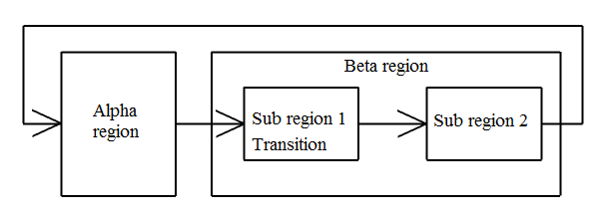

Figure 6.5: Transition between different regions.

## Control structure design

In order for the model predictive controller to be as simple as possible, some control loops, in particular frost protection, air heater and main flow controller, were excluded from the MPC design. These control loops are not heavily affected by disturbances form Hafslund. PI controllers were therefore designed for these control loops.

The MPCs had therefore a total of four manipulated variables, the bypass valve, the heat exchanger valve, and the air cooler fan and valve. Since it is assumed that the two heat exchanger lines are almost identical, an MPC developed for heat exchanger line 1 also will work for line 2, and since EGE do not control any valves at Hafslund side of the heat exchanger, EGE do not violates Hafslund’s control structure.

It was decided to let the MPC control directly on manipulated inputs, and reasons for this are

* The main flow at Brobekk is already controlled.
* The flow in through the bypass or the primary side of the heat exchanger is not measured.

However, when the plant is in the β region, one alternative for controlling the heat exchanger secondary side outlet temperature could be to let the MPC calculate a setpoint for the heat exchanger primary side flow. A flow controller could then control this flow. The rest of the flow in the plant would then go through the air cooler, which needs to be left uncontrolled. But this is not possible because obvious reason above.

### PI controllers

Steady state gain *k* and time constant *τ1* were obtained by using step responses and then approximation of a first-order transfer function model. The tuning parameters for PI controllers were then found using Skogestad/Simple Internal Model Control (SIMC) (Skogestad, 2003).

The controller gain and integral action are given by.





Table 6.1: PI Controller parameters.

|  |  |  |  |  |  |  |
| --- | --- | --- | --- | --- | --- | --- |
| Controller | *k* | *τ1* | *θ* | *τc* | *Kc* | *τi* |
| Air heater | 90 | 100 | 1 | 1 | 0.55 | 8 |
| Air cooler – frost protection | 4800 | 2423 | 100 | 100 | 0.0025 | 800 |
| Brobekk flow controller[1] | 5.342 ∗10-3 | 9.43 | ≪1 | ≪1 | 37 | 0.2 |

It was decided to set the tuning parameter *τc* equal to *θ.* This gives a reasonably fast response with moderate input usage and good robustness margins (Skogestad, 2003). The controllers were modelled using a standard PI controller equation . The open loops responses are shown in appendix C.



(a) shows the air temperature toward the furnace follows its setpoint at 90°C. The flow through the air heater secondary side was set to 6 kg/s. (b) shows the disturbances that affect the air temperature towards the furnace, which is the primary side inlet temperature and primary side flow. The outside air temperature was set to 0°C.

(a) shows that frost protection controls the temperature trajectory inside the air cooler. At time 8000 sec the temperature controller in frost protection system starts to stabilize temperature at 10°C. (b) shows the flow through the air cooler valve, which is used to stabilize the temperature inside the air cooler. (c) shows the flow inside the air cooler, which always is 15.125 kg/s, and the flow driven by the frost protection pump, which depends on the flow through the air cooler valve. The outside air temperature was set to 0°C.

shows the flow towards the furnace. The setpoint for this flow is 250 tonne/h, which is in accordance with the operational aspect at Brobekk.



(a)



(b)

Figure 6.6: Air temperature towards the furnace and disturbances.

(a)(b)



(c)

Figure 6.7: Temperature and flow inside air cooler.



Figure 6.8: Main flow at Brobekk.

### MPC design - Alpha region

In the α region, EGE can never achieve the heat exchanger secondary side outlet temperature, *y10 ,* that Hafslund wants, will therefore not make sense to control this variable. Thus EGE only has one variable to control, namely the furnace inlet temperature, *y1.* Because EGE do not want to remove some heat in this region, they have to close the air cooler valve, *u7* and air cooler fan, *u3*. EGE now has two manipulated variables left, the bypass valve *u7* and heat exchanger valve *u6* and one controlled variable, making this a “fat” plant. As mentioned in chapter that in the “fat” plant case one need setpoint for extra manipulated variables, usually to improve economical return or safety. From an economical point of view, EGE will have as much water as possible through the heat exchanger, thus having the heat exchanger valve fully open at all time. If the heat exchanger valve is fully open, EGE only has one manipulated variable and one control variable which is an optimal solution.

### MPC design - Beta region

As mentioned earlier, the β region is quite challenging to control, first of all because of the gains changes, and also because both the air cooler valve and the air cooler fan are dependent on each other. The air cooler fan will not affect furnace inlet temperature if the air cooler valve does not open, and the air cooler valve will operate at as hot bypass if the fan does not start.

As discussed in chapter the bypass valve has to be closed when EGE operates in the β region, and in chapter it was discovered that it is only possible to control one outlet temperature, if one of the flows through the heat exchanger and both the inlet temperatures are fixed, i.e. not possible to manipulate them. Since both the inlet temperatures and the flow through the secondary side at the heat exchanger are fixed and EGE controls the heat exchanger secondary side outlet temperature, it is not possible to control the heat exchanger primary side outlet temperature independently. The same goes for the air heater, because both the inlet temperatures and flow through the secondary side are fixed, and EGE controls the secondary side outlet temperature. This means that EGE only can control the furnace inlet temperature with the flow from the air cooler and fan duty, because it is not possible to control the air heater and heat exchanger primary side outlet temperature independently. Therefore three different MPCs has to be developed for the β region, one for each sub region, except from sub region 4.

## Simulations

This section shows simulations of different MPC alternatives for both α and β region. MPC parameters are shown in Table 6.2 through .

The internal models needed for the MPC were found using linear analysis in Simulink. The basic model was the Simulink model developed by Smedsrud in his master thesis and modified in this thesis. Appropriate manipulated and measured variables were chosen and then different internal models could be obtained by doing a linear analysis of the basic model with steady state values. The internal model derived from the linear analysis above had between 90-80 states; it was therefore decided to do a model reduction of the model. Since the internal models are linear, a model reduction can easily be done in MATLAB. The appropriate reduced model order should be greater or equal to the number of dominant singular Hankel values. It was found that the appropriate model order should be 20. After the model reductions were done, different MPCs could be developed and implemented. All the simulations were done in Simulink.

Some of the parameters shown below are tuning parameters; according to Maciejowski, (2002) tuning parameters are *weighting matrices*, *prediction horizon*, *and observer* and *disturbance model dynamics*. A specific disturbance model was not included, so the Model Predictive Control toolbox had to generate one.

Large weights on measured outputs were needed to ensure good control, large weights on manipulated variables rate of change were needed to ensure smother response and large weights were needed on manipulated variables to prevent them from moving. The control interval, prediction and control horizon was determined based on the tuning rules proposed in chapter .

### Alpha region

Only one control structure was considered for the α region. Large weights were put on heat exchanger valve, and air cooler fan and valve, to prevent these manipulated variables to move away from its setpoint. The setpoint was set is set to one for the heat exchanger valve and zero for the air cooler fan and valve. The bypass valve is not weighted at all, meaning that it can move freely within its operating space. The only weighted output is the furnace inlet temperature and the setpoint was 126°C. The MPC parameters are shown in Table 6.2.

Table 6.2: Parameters for MPC constructed for α region.

|  |  |
| --- | --- |
| **Internal Model** | |
| Order | 20 |
| Manipulated variable | *u=*[*u8 u6 u3  u7*]T |
| Measured variables | *y=*[*y12 y7 y1  y10 y8*]T |
| Measured disturbances | *d=*[*d1 d2*]T |
| **Tuning parameters** | |
| Control interval | 30 |
| Prediction horizon | 20 |
| Control horizon | 3 |
| Manipulated variable setpoints | [1 0.4 0 0]T |
| Manipulated variable weighting | diag(*Ru*) = [10000 0  1000000 1000000] |
| Manipulated variable rate of change weighting | diag(*R∆u) =* [1000 10000 1000000 1000000] |
| Measured outputs weighting | diag(*Qy)=* [0 0 10000 0 0] |
| **Constraints specifications** | |
| Minimum MV | *u*min = [0.55 0 0 0]T |
| Maximum MV | *u*max = [1 1 90000 1]T |
| Minimum rate of change MV | ∆*u*min = -[0.02 0.05 5000 0.02]T |
| Maximum rate of change MV | ∆*u*max = [0.02 0.05 5000 0.02]T |

No specific constraints were defined for measured outputs and no additional tuning was done for the observer and the disturbance model, meaning that the default settings were used.

(a) shows that the furnace inlet temperature follows its setpoint excellently. The maximum deviation is approximately 0.5°C, which is within the measurement accuracy. (b) shows how the heat exchanger secondary side outlet temperature varies. And it can be seen that the heat exchanger outlet temperature never reaches the temperature that Hafslund wants. Temperature, flow and heat demand from Hafslund are shown in . The heat demand is found by using equation . shows how the manipulated variables vary during the simulation. The heat exchanger valve is almost fully open at all time while the bypass valve is used to control the furnace inlet temperature. The small drops in the heat exchanger valve are because the valve is not enough heavily weighted compared to the other variables. But the drops are less than 5% of the maximum valve opening, so it is believed that these drops do not affect the control much. Most of the time, the valve is fully open. Plots of air cooler fan and valve are not shown because they are not used in the α region.



(a)



(b)

Figure 6.9: Figure (a) shows furnace inlet temperature and figure (b) shows the heat exchanger secondary side outlet temperature in the α region.



Figure 6.10: Manipulated variables in the α region.



Figure 6.11: Flow, temperature and heat demand from Hafslund in the α region.

### Beta region

Two control structures developed for the β region is shown in this thesis. They are almost identical, but the difference between the two alternatives is the setpoint for the heat exchanger secondary side outlet temperature. Several other control structures were also tested, including the one where the Brobekk bypass valve was used, but none of them seemed to give promising results, and there are therefore not shown here.

##### Alternative 1

In alternative 1, there are three manipulated variables, the heat exchanger valve, *u8* and air cooler fan *u3* and valve *u7,* and two control variables, the furnace inlet temperature, *y1* and heat exchanger secondary side outlet temperature, *y10*. The setpoint for the furnace inlet temperature was 126°C and the setpoint for the heat exchanger secondary side outlet temperature was equal to the setpoint for the temperature towards Oslo, *y11*. Therefore Hafslund do not has to use their bypass valve to control the temperature towards Oslo, and this bypass valve should be closed all the time.

Table 6.3: Parameters for MPC constructed for β region[2].

|  |  |
| --- | --- |
| **Internal Model** |  |
| Order | 20 |
| Manipulated variable | *u=*[*u8 u6 u3  u7*]T |
| Measured variables | *y=*[*y12 y7 y1  y10 y8*]T |
| Measured disturbances | *d=*[*d1 d2*]T |
| **Tuning parameters** |  |
| Control interval | 30 |
| Prediction horizon | 20 |
| Control horizon | 3 |
| Manipulated variable setpoints | *u*Target = [1 0 5000 0.5]T |
| Manipulated variable weighting | diag(*Ru*) = [100 500000  0 50] |
| Manipulated variable rate of change weighting | diag(*R∆u) =* [100000 10000 10 10000] |
| Measured variables weighting | diag(*Qy)=* [0 0 10000 7500 0] |
| **Constraints specifications** |  |
| Minimum MV | *u*min = [0 0 0 0]T |
| Maximum MV | *u*max = [1 1 90000 1]T |
| Minimum rate of change MV | ∆*u*min = -[0.02 0.05 5000 0.02]T |
| Maximum rate of change MV | ∆*u*max = [0.02 0.05 5000 0.02]T |

No specific constraints were defined for measured outputs and no additional tuning was done for the observer and the disturbance model, meaning that the default settings were used. As seen from , large weight was put on the bypass valve to prevent it from move away from it setpoint, which was set to zero, and small weights were put on the heat exchanger valve, and air cooler fan and valve so they could move freely. In addition to having large weight on the furnace inlet temperature, large weight was put on the heat exchanger secondary side outlet temperature.

(a) shows furnace inlet temperature. The deviation is slightly larger than for the α region, 1.5°C against 0.5°C, but overall the control is good. At time step 6000 Hafslund changes the setpoint for the temperature towards Oslo and the controller needs some time to bring the furnace inlet temperature back to its setpoint. shows the inlet temperature, flow and heat demand from Hafslund. As seen from (b), the heat exchanger secondary side outlet temperature follows its setpoint well. The maximum deviation is less than 1°C. The bypass valve at Hafslund was closed during simulation, so the temperature shown in (b) will be the temperature towards Oslo. shows how the manipulated variables vary during simulation. The bypass valve at Brobekk is closed during the whole simulation while the manipulated variables varies.



(a)



(b)

Figure 6.12: Figure (a) shows furnace inlet temperature and figure (b) shows the heat exchanger secondary side outlet temperature in the β region alternative 1.



Figure 6.13: Manipulated variables in the β region alternative 1



Figure 6.14: Flow, temperature and heat demand from Hafslund in the β region.

##### Alternative 2

In alternative 2, the heat exchanger secondary side outlet temperature setpoint was 2°C higher than the setpoint for the temperature towards Oslo, thus Hafslund uses their bypass valve to control the temperature towards Oslo. The MPC developed for alternative 1 was used in alternative 2, as well as the same temperature and flow from Hafslund. (a) shows that the furnace inlet temperature varies a lot more than in alternative 1, but the deviations in temperature never exceeds ±2°C. The heat exchanger secondary side outlet temperature varies even more and the deviations is somewhere about 7°C. shows the flow through the heat exchanger secondary side. The flow varies a lot and this again affects the furnace inlet temperature and the heat exchanger primary side outlet temperature. This variation in flow is caused by the bypass valve at Hafslund side, if the valve opens, less water will flow through the heat exchanger and vice versa. shows the temperature towards Oslo and it follows the setpoint exceptionally good on the expense of more variations in temperature at Brobekk’s side of the heat exchanger.



(a)



(b)

Figure 6.15: Figure (a) shows furnace inlet temperature and figure (b) shows the heat exchanger secondary side outlet temperature in the β region alternative 2.



Figure 6.16: Temperature towards Oslo in the β region alternative 2.



Figure 6.17: Flow secondary side Heat exchanger in the β region alternative 2.



Figure 6.18: Manipulated variables in the β region alternative 2

### Transition from alpha to beta region

One way to switch from the α region to the β region, is to set the setpoint for the air cooler valve at for example 0.5 and then weight it heavily. This will cause the valve to open. It is important not to open the air cooler valve too fast, because this will cause a large amount of cold water flowing to the furnace in a short time. Constraints were therefore put on manipulated variable rate of change. The bypass valve should not be weighted at all, because this is needed to control the furnace inlet temperature. The air cooler fan should also be turned off during the transition. This can be done by setting the setpoint for the air cooler fan equal to zero and weight it heavily. All the MPC parameters are shown in and simulations are shown in to .

Table 6.4: Parameters for MPC constructed for β sub region 1.

|  |  |
| --- | --- |
| **Internal Model** |  |
| Order | 20 |
| Manipulated variable | *u=*[*u8 u6 u3  u7*]T |
| Measured variables | *y=*[*y12 y7 y1  y10 y8*]T |
| Measured disturbances | *d=*[*d1 d2*]T |
| **Tuning parameters** |  |
| Control interval | 30 |
| Prediction horizon | 20 |
| Control horizon | 3 |
| Manipulated variable setpoints | *u*Target = [1 0 0 0.5]T |
| Manipulated variable weighting | diag(*Ru*) = [100 0  100000 100000] |
| Manipulated variable rate of change weighting | diag(*R∆u) =* [100000 0 10 10000] |
| Measured variables weighting | diag(*Qy)=* [0 0 10000 7500 0] |
| **Constraints specifications** |  |
| Minimum MV | *u*min = [0 0 0 0]T |
| Maximum MV | *u*max = [1 1 90000 1]T |
| Minimum rate of change MV | ∆*u*min = -[0.02 0.2 5000 0.01]T |
| Maximum rate of change MV | ∆*u*max = [0.02 0.2 5000 0.01]T |

(a) shows the furnace inlet temperature and the temperature decreases a little, before it increases and the goes back to the setpoint. The maximum deviation is about 3°C. This response also depends on how cold the water accumulated in the air cooler is. (b) shows the heat exchanger secondary side outlet temperature, and this also varies some, but the MPC is able to bring the temperature back to its setpoint. shows how the manipulated variable varies. The air cooler valve opens slowly and the bypass valve is used to control the furnace inlet temperature. shows the heat demand form Hafslund, the air cooler primary side outlet temperature, and the MPC used. When the heat demand from Hafslund drops below 32 MW, the plant enters sub region 1, and thus the MPC developed for this region is used. When the air cooler primary side outlet temperature goes above the furnace inlet temperature, the control system enters sub region 2 and switches to the MPC developed for this region. The switching between the different regions are marked with arrows.



(a)



(b)

Figure 6.19: Figure (a) shows furnace inlet temperature and figure (b) shows the heat exchanger secondary side outlet temperature. Switching from α to β.



Figure 6.20: Manipulated variables. Switching from α to β.



Figure 6.21: Heat demand from Hafslund, Temperature in the Air cooler and MPC used. Switching from α to β.

### Transition from beta to alpha region

When the plant enters the α region, the only control objective is to control the furnace inlet temperature. EGE should close the air cooler fan and valve, and open the bypass valve. The plant enters the α region when the heat demand from Hafslund goes above 32 MW, and this can be seen in . shows that transition from the β region to the α region worked well, the furnace inlet temperature varies some, but the maximum deviation is about 1°C. shows that the air cooler valve and fan closes while the bypass valve opens, the bypass valve opens exactly when Brobekk enters the α region.



(a)



(b)

Figure 6.22: Figure (a) shows furnace inlet temperature and figure (b) shows the heat exchanger secondary side outlet temperature. Switching from β to α.



Figure 6.23: Manipulated variables. Switching from β to α.



Figure 6.24: Heat demand from Hafslund and MPC used. Switching from β to α.

# 

# Conclusion

The main focus if this work has been to implement a Model Predictive Control at Brobekk waste incineration plant, in addition the model of the plant had to be modified, due to physical modification at Brobekk. Based on the operational aspects at Brobekk, the control region was divided into two distinct regions, named α and β, where the β region could be divided into four different sub regions. Four different MPCs were developed, one for the α region, one for each sub region, except sub region 4. Unfortunately, no simulations were done for the sub region 3, due to the difficulties with forcing the model to enter this region.

Considerations of the different MPCs developed in this thesis; it seems that all of them give promising control over the furnace inlet temperature and the heat exchanger secondary side outlet temperature. In alternative 1 for the β region, the control structure developed here seems to promise good control of both the furnace inlet temperature and the temperature towards Oslo, satisfying both EGE’s and Hafslund’s demands. In alternative 2 for the β region, it was found that the bypass valve at Hafslund’s side interferers with the temperatures within Brobekk, causing more variations in the furnace inlet temperature. But the temperature towards Oslo follows its setpoint excellently. Since we assume that it is more important to have a constant furnace inlet temperature then it is to follow the setpoint to Hafslund, we suggest using alternative 1.

An alternative is to still use alternative 2, and then let the Hafslund bypass valve be “slowly” tuned. This might decrease the variations in the furnace inlet temperature and heat exchanger secondary side outlet temperature. But it is unknown how “slow” the bypass valve should be tuned, and probably the performance will not be better than in alternative 1.

Overall, it is concluded that the proposed control structure controls the plant very well, when EGE only controlling valves at Brobekk side of the heat exchanger.

Based on this work, the following topics can be investigated in further work.

* Investigate how additional tuning for the observer and disturbance model can improve the control even more.
* Investigate how the transition between the two regions can be improved. Maybe if the temperature and flow from the air cooler are measured as a disturbance can improve the control.

# 

# Bibliography

Froisy, J. B. (1994). Model predictive control: Past, present and future. ISA Transactions, 33, 235–243.

Hertzberg, T. (2008). Lecture notes.

Hovd, Morten. (2009). Model-based predictive control. Lecture notes from the course Advanced Control of Industrial Processes, Department of Engineering Cybernetics, NTNU.

Imsland, Lars. (2007). Introduction to Model Predictive Control. Lecture notes from the course Optimization and Control, Department of Engineering Cybernetics, NTNU.

Kern, D.Q. (1950). Process Heat Transfer. McGraw-Hill, int. Ed.

Maciejowski, J. M. (2002). Predictive Control with Constraints. Prentice Hall.

Markus, L. & Lee, E. (1967). Foundations of optimal control theory. J. Wiley, New York.

Mathisen, K.W. (1994), Integrated design and Control of Heat exchanger Networks. PhD thesis, NTH, Department of Chemical Engeineering..

Mordt, H. (2010), Private correspondence.

Qin, S. J. & Badgwell, T. A. (2003). A survey of industrial model predictive control technology. 03, 733–765.

Rosenbrock, H.H. (1970). Process Control System, 2nd edition. McGraw-Hill, USA, 227-230.

Shinskey, F.G. (1979). Process Control System 2nd edition. McGraw-Hill, USA, 227-230.

Skogestad, S. (2003). Simple analytic rules for model reduction and PID controller tuning. Journal of Process Control 13 (2003) 291-309.

Skogestad, S. (2004). Control structure design for complete chemical plant. Computers and Chemical Engineering 28 (2004) 219-234.

Skogestad, S. & Postlethwaite, I. (2005). Multivariable Feedback Control. John Wiley & Sons, Ltd, 2nd edition. 2007.

Smedsrud, H. (2007). Dynamic Model and Control of heat exchanger networks. 5th year project work at the Department of Chemical Engineering. NTNU

Smedsrud, H. (2008). Dynamic Modeling and Control of Brobekk Incineration Plant. Master thesis at the Department of Chemical Engineering. NTNU

The MathWorks, Inc. (2004). Model Predictive Control Toolbox, user guide, v2, 2004 <http://www.chbe.gatech.edu/lee/chbe6400_2006/files/mpc_toolbox.pdf>

Ziegler, J.G. & Nichold, N.B. (1943). Process Lags in Automatic-Control Circuits. Trans. ASME, 65, 433-44

# Appendix A - List of symbols

|  |  |  |
| --- | --- | --- |
| Latin symbols | | |
| Symbol | Description | Unit |
| *A* | Area | m2 |
| *cp* | Specific heat capacity | J kg-1 K-1 |
| *d* | Disturbance | ... |
| *h* | Heat transfer coefficient | W m-2 K-1 |
| *N* | Number of cells | - |
| *P* | Power | W |
| *p* | Pressure | Pa |
| *q* | Conducted heat | W |
| *Q* | Volumetric flow rate | m3 h-1 |
| *T* | Temperature | °C |
| *t* | Time | Second |
| *u* | Manipulated variable | ... |
| *V* | Volume | m3 |
| *w* | Mass flow rate | kg s-1 |
| *y* | Measured variable | ... |

|  |  |  |
| --- | --- | --- |
| Greek symbols | | |
| Symbol | Description | Unit |
| *η* | efficiency | ... |
| *ρ* | Density | kg m-3 |

|  |  |
| --- | --- |
| Superscript symbols | |
| Symbol | Description |
| *p* | Primary side |
| *s* | Secondary side |
| *w* | Wall side |

|  |  |
| --- | --- |
| Subscript symbols | |
| Symbol | Description |
| *in* | Inlet |
| *out* | Outlet |

# Appendix B - Model parameters

The tables below contain the parameters that were used in the simulations.

|  |  |  |  |  |  |  |
| --- | --- | --- | --- | --- | --- | --- |
| General parameters. | | |  | Heat exchangers parameters. | | |
| Symbol | Value | Unit |  | Symbol | Value | Unit |
|  | 912.892 | kg m-3 |  | *A* | 74.6 | m2 |
|  | 859.049 | kg m-3 |  | *Vp* | 0.2667 | m3 |
|  | 80300 | kg m-3 |  | *Vs* | 0.3492 | m3 |
|  | 0.9285 | kg m-3 |  | *Vw* | 0.3730 | m3 |
|  | 1.161 | kg m-3 |  | *N* | 10 | - |
|  | 1000 | kg m-3 |  | *hp* | 9796.09 | W m-2 K-1 |
|  | 4321.84 | J kg-1 K-1 |  | *hs* | 9796.09 | W m-2 K-1 |
|  | 4213.84 | J kg-1 K-1 |  |  |  |  |
|  | 5030 | J kg-1 K-1 |  |  |  |  |
|  | 1018.5 | J kg-1 K-1 |  |  |  |  |

|  |  |  |  |  |  |  |
| --- | --- | --- | --- | --- | --- | --- |
| Air cooler parameters. | | |  | Air heater parameters. | | |
| Symbol | Value | Unit |  | Symbol | Value | Unit |
| *A* | 74.6 | m2 |  | *A* | 30.71 | m2 |
| *Vp* | 0.2667 | m3 |  | *Vp* | 0.12656 | m3 |
| *Vs* | 0.3492 | m3 |  | *Vs* | 0.12656 | m3 |
| *Vw* | 0.3730 | m3 |  | *Vw* | 0.3730 | m3 |
| *N* | 10 | - |  | *N* | 3 | - |
| *hp* | 9796.09 | W m-2 K-1 |  | *hp* | 25 | W m-2 K-1 |
| *hs* | 9796.09 | W m-2 K-1 |  | *hs* | 51 | W m-2 K-1 |
| *Tair[3]* | 0 | °C |  | *wair[4]* | 6 | kg s-1 |
|  |  |  |  | *Tair1* | 0 | °C |

|  |  |  |  |  |  |  |
| --- | --- | --- | --- | --- | --- | --- |
| Furnace parameters. | | |  | Flow factors. | | |
| Symbol | Value | Unit |  | Symbol | Value | Unit |
| *UA* | 52250.6 | W K-1 |  | *Kv,u5* | 92.528 | m3 h-1 bar-1 |
| *Tair 1* | 1000 | °C |  | *Kv,u6* | 83.303 | m3 h-1 bar-1 |
| *wair* | 19.86 | kg s-1 |  | *Kv,u7* | 260.321 | m3 h-1 bar-1 |
|  |  |  |  | *Kv,u8* | 260.321 | m3 h-1 bar-1 |

|  |  |  |  |  |  |  |
| --- | --- | --- | --- | --- | --- | --- |
| Fan parameters. | | |  | Pump parameters. | | |
| Symbol | Value | Unit |  | Symbol | Value | Unit |
| *∆p* | 1000 | Pa |  | *p0* | 15 | bar |
| *Tair* | 0 | °C |  | *η* | 0.9 | - |
| *A* | 3.14 | m1 |  |  |  |  |
| *z* | 0.6 | - |  |  |  |  |
| *η* | 0.9 | - |  |  |  |  |

|  |  |  |  |  |  |  |
| --- | --- | --- | --- | --- | --- | --- |
| Disturbances | | |  |  | | |
| Symbol | Value | Unit |  |  |  |  |
| *d1* | 65-90 | °C |  |  |  |  |
| *d2* | 500-900 | tonne/h |  |  |  |  |

# Appendix C - Open loop step responses

Open loop responses used to find tuning parameters for PI controllers



Figure C.1: Open loop step response for air heater.



Figure C.2: Open loop step response for Air cooler – frost protection.



Figure C.3: Open loop step response for main flow controller.

1. The controller parameters for the main flow controller had to be retuned because SIMC gave a too high controller gain.
2. The MPC parameters given in are only valid for sub region 2 and 3. MPC parameters for sub region 1 are given in .
3. Secondary side inlet temperature to the air cooler and air heater.
4. Secondary side flow through the air heater. This was set to be a fixed value.