Ontological framework for the implementation of waste minimisation methodologies into process industries

Adriana Reyes-Córdoba, Paul Sharratt, Jorge Arizmendi-Sánchez

The University of Manchester, PO Box 88 M60 1QD, Manchester, UK

Abstract

Successful and widespread implementation of existing methodologies for waste minimisation has failed to provide significant benefits for industrial applications because there is not a comprehensive approach that integrates and guides the application of the proper tool depending on the case. Each of these methodologies has been developed for particular stages in the process life cycle and they require different information which may not be available and could result too costly to obtain. The aim of this work is to present the theoretical framework of a tool which integrates these methodologies and provides criteria to select the appropriate structure for the case at hand. The tool explored for this effect is an ontology-based approach for the structured organisation of information aiming to identify significant waste minimisation opportunities.

**Keywords:** waste minimisation, ontology, information.

* 1. Introduction

Many methodologies for waste minimisation in the process industries have been created in order to decrease the need to deal with waste using end of pipe technologies. Still sometimes waste minimisation methodologies are underestimated or disregarded due to several misconceptions about their applicability. One reason believed to cause this is the lack of suitable procedures for the identification of suitable waste reduction techniques. This is in turn thought to arise from a mismatch between the available methodologies and the information available at the time of the study.

Waste generation within a process has to be analysed from the different aspects that cause it. This involves not only the manufacturing process but also other stages of product’s life such as raw material storage and preparation, logistics of the overall process or product preparation for distribution [1]. Different groups of staff within an industry interact in different ways with the activities that generate waste and hold pieces of information about the causes. The effective gathering, representation and modelling of information from all these staff groups is essential to ensure integration and success of the different waste minimisation actions.

* 1. Waste minimisation

Waste minimisation can be defined as: “The reduction or elimination of the generation of waste at source through the efficient use of raw materials, energy and water” [2]. In order to support the implementation of waste minimisation in process industries, several methodologies for waste minimisation have been proposed, these can be divided into qualitative and quantitative and include auditing tools. Amongst the main methodologies are: the Environment Agency approach [2], Process integration for pollution prevention [3], DuPont’s methodology [4], LCA for process optimisation OLCAP [1], ENVOP [5] and ENVOPexpert [6].

Figure 1 includes an overview of the methodologies mentioned integrated into the overall environment agency approach. The diagram shows in the part of data analysis, a list of important information inputs needed for the whole process of waste minimisation. It also highlights the need for the selection of a team of experts and the need for adequate criteria to select correct options for improvement.

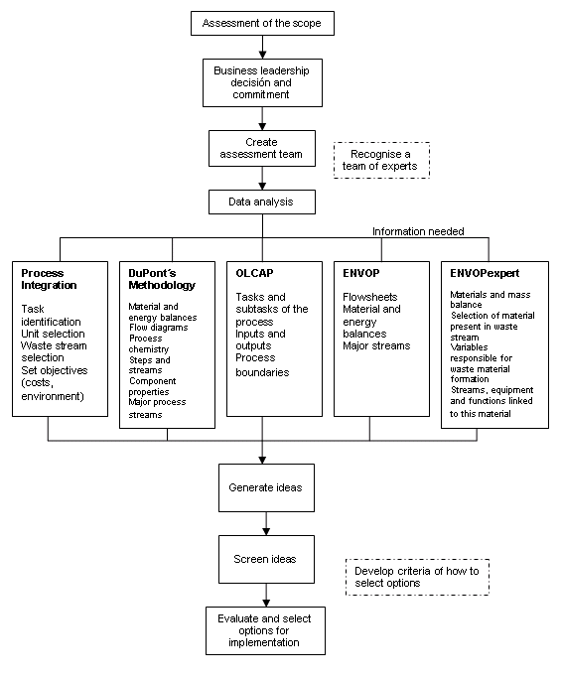

Figure . Overview of the steps suggested for waste minimisation

* + 1. Challenges for the current approach to waste minimisation

Waste management costs are higher than many companies realise, yet sometimes a strong resistance against waste minimisation plans or even ignorance about the topic can be found. The reasons found for this are generally related to manpower, knowledge, economics, time and technology resources being managed in an inadequate way.

Available knowledge and information can restrict or limit what can be done for environmental protection in a company. The organisation might not know their pollution load in order to determine whether it is significant and able to address the environmental problem in a more specialised way. They might not know about the different ways they can address pollution prevention or how to implement a certain waste minimisation plan. Current approaches for waste minimisation deal with process design and operation, leaving aside the importance of having the right information about process problems in the right time to help effective decision making in practice.

* 1. Proposed framework for a new waste minimisation tool

In order to overcome the difficulties found in the application of waste minimisation methodologies, we propose an approach that considers the identification of the applicability of each methodology and tool depending on the type or problem or stage of the process lifecycle. We also propose the adaptation of the existing methodologies into a flexible knowledge management approach that uses the quality and quantity of information available. In order to achieve these objectives, we propose the use of an ontological structure to support the classification of information as described in the following sections. This approach should enable the identification of missing key information, guide the gathering of such required information and provide a link to the applicable methodology and tool for the successful identification of waste minimisation solutions. The proposal presented in this paper follows the generic steps depicted in Figure 2.

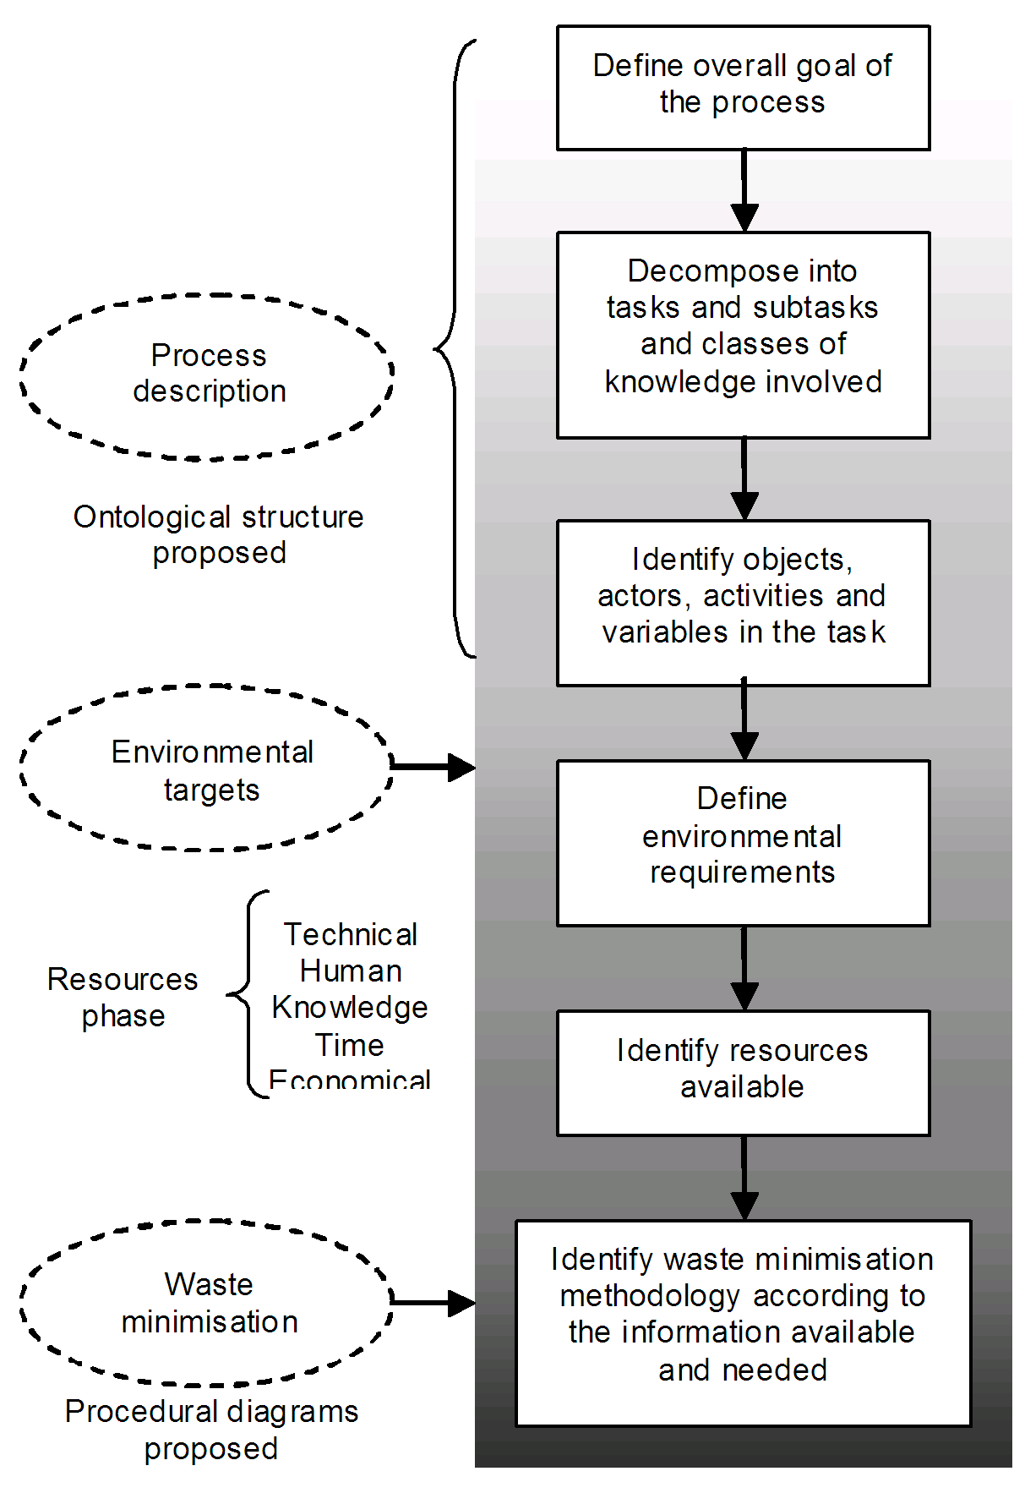

Figure . Structure of the proposed methodology

The proposed approach starts with the definition of the environmental requirements or benefits of a plan for waste minimisation. It then follows taking into account that effective gathering, representation and modelling of information from all the staff levels within the process is essential to ensure integration and success of the different waste minimisation actions. The methodology divides knowledge about a process into five main classes which contribute in different levels to the successful application of waste minimisation tools.

* *Crucial* knowledge is the one responsible for the initial description of the process.
* *Prior* knowledge refers to the information obtained previously about objects, actors and actions needed to perform a task.
* *Subordinate* knowledge is the one without which, the performance of the process might be unsatisfactory or unsuccessful.
* *Contextual* knowledge refers to the contribution of any situation affecting the perception of the actors or performance of the objects, such as psychological or environmental restrictions.
* *Causal* knowledge is identified as relationships between objects and variables.

The proposed approach links all resources available with the different classes of knowledge associated. The relationships between the five classes of knowledge are directly associated with interactions between the agents involved in each process task. These agents are responsible for the performance of the action and are divided into objects, actors, variables and activities. Objects are defined as the physical instruments through which the task is being performed, actors are the human resources in charge of controlling or performing the task, variables are properties that change during the task and activities are the actions that have to be performed to fulfil a task or subtask.

* + 1. Features of the proposed ontology for waste minimisation

The proposed ontology is used to organise the information derived from the steps considered by the general methodology shown in Figure 2. The ontology is used to arrange the information describing the process in hierarchical classes and establish the relationships between its parts. Furthermore, it aims to provide answers to questions including, for example, which environmental requirements are not being complied, what kind of information is needed to describe the non-compliance, how this information is obtained, what kinds of waste minimisation options are available and which resources are needed to implement them.

The approach developed considers the construction of an ontology that addresses simultaneously four key aspects shown in Figure 3. These aspects include issues defining environmental compliance for the case under study; a description of the process including the different objects and activities that have to be performed to achieve the specific goal of the process; the resources available for the company; and the specific steps to be followed for waste minimisation plans.

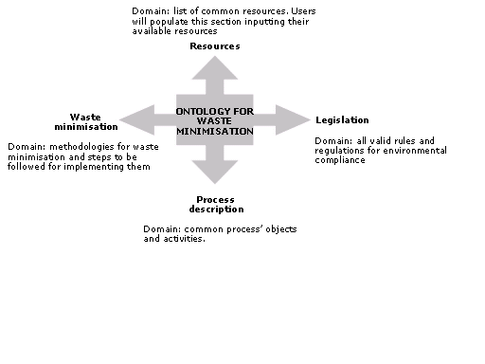

Figure . Key domains for the ontology for waste minimisation

* + - 1. Environmental compliance

To obtain awareness of an industry’s environmental load it is needed first to understand its environmental requirements. The presented approach includes a part of the ontology in which the knowledge needed about environmental rules, regulations and requirements is embedded.

* + - 1. Description of the process

As discussed previously methodologies for waste minimisation often rely on the availability and accuracy of information about the process. However, this information might not be linked between different sources. Knowledge about an isolated part of the process might be in an abstract format which is not compatible with other information sources. The available process knowledge has been organised within an ontology-based framework, the information categories are compared with the resources needed and available for the adequate analysis that generates options for the optimal performance of the actual process being studied. A fraction of the OntoCAPE ontology [7] is reused as a platform for the process description phase, following the recommendations of generic ontology development. The focus will be on the information requirements for the process, the physical plant, the materials occupied and the costs involved.

* + - 1. Available resources

Waste minimisation presents several obstacles for the process industries based on the availability of resources. These resources will be assessed from the different kinds of knowledge they possess using the analysis of the levels of knowledge presented in section five.

* + - 1. Waste minimisation

Finally, the waste minimisation methodologies studied previously are organised in a section of the ontology which provides a step-by-step guidance about each of them. A format similar to the guidelines approach proposed by Venkatasubramanian et al [8] has been followed in order to provide a structured overview of the guidelines to follow. These are translated in specific knowledge to guide decision making for structuring waste minimisation plans tailored for the specific company under study.

* 1. Case study

As an exercise to illustrate the first stage of the proposed methodology, the case of a catalytic reactor has been studied. The reaction carried out in this unit transforms A into B by contact with catalyst C with heat release, additionally, the product B is rapidly decomposed into D which is an undesired byproduct. An initial description of the concepts defining the function of the reactor is provided by the process description ontology and is depicted in Figure 4.



Figure . Catalytic reactor analysis of concepts

The catalytic reactor has two main tasks: carry out catalytic reaction and quench reaction gases. From these tasks and the previous description it is then possible to construct a knowledge block for the unit shown in Figure 5.

The causal information level provides the first waste minimisation opportunity by means of the exothermic nature of the reaction. This characteristic can be further exploited into the creation of a heat exchange network by the use of process integration tools.

The next step is to analyse the remaining components of the knowledge block to find out which information is already available to implement the waste minimisation methodology proposed. This is accomplished with the aid of the resources ontology which is currently under development.



Figure . Knowledge block for the catalytic reactor

* 1. Conclusions and further work

The methodological framework presented proposes the use of information modelling and ontological structures to analyse and manage information from various sources with the purpose of finding opportunities for waste minimisation. The methodology presented in this paper is still under construction and aims to identify and manage key required information to analyse specific processes and derive waste minimisation strategies based on the application of the adequate methodology according to the information requirements.

The present works proposes the integration of waste minimisation into the field of knowledge representation through ontologies. It has been recognised that ontologies can be used to organise knowledge and therefore tackle different areas without disregarding relevant issues. Waste minimisation methodologies need a tool that considers the complexity of the knowledge that has to be gathered for their correct performance. A systematic approach to organise this knowledge such as the construction of an ontology will therefore result in a more practical way to understand and apply this knowledge.

References

1. Azapagic, A. and R. Clift, *The application of life cycle assessment to process optimisation.* Computers and Chemical Engineering, 1999. **23**: p. 1509-1526.

2. Envirowise. *The cost of your waste is not so much the cost of getting rid of it as the value of what you are getting rid of*. 1998 [cited.

3. Sikdar, S. and M. El-Hawagi, *Process design tools for the environment*. 1st edition ed. 2001, New York, USA: Taylor & Francis.

4. Douglas, J., *Process Synthesis for Waste Minimization.* Ind. Eng. Chem. Res., 1992. **32**: p. 238-243.

5. Isalski, W.H., *ENVOP for waste minimization.* Environmental Protection Bulletin, 1995. **34**(16).

6. Halim, I. and R. Srinivasan, *Systematic Waste Minimization in Chemical Processes. 1. Methodology.* Ind. Eng. Chem. Res., 2002(41): p. 196-207.

7. Morbach, J., A. Yang, and W. Marquardt, *OntoCAPE- A large-scale ontology for chemical process engineering.* Engineering applications of artificial intelligence, 2007. **20**: p. 147-161.

8. Zhao, C., et al., *Toward intelligent decision support for pharmaceutical product development.* Journal of Pharmaceutical Innovation, 2006: p. 23-35.